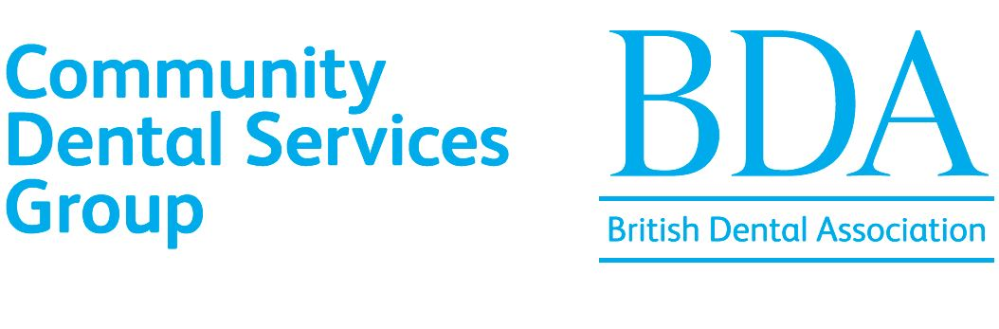
BDA CDS Group Annual Presidential and Scientific Meeting 2026
Venue Cymru, The Promenade, Llandudno LL30 1BB
Thursday 8 and Friday 9 October 2026

Poster Presentation Application Form

Title of Poster

……………………...............................................................................................

Category (please mark the relevant box)
Clinical Case Poster
Service Improvement Poster

Abstract (Maximum 100 words)
……………………...............................................................................................……………………...............................................................................................……………………...............................................................................................

Author(s)

…………………..............................................................................................

Name of author(s) attending conference

……………………...............................................................................................
Has the author(s) booked to attend the conference? Yes/ No

Employing Trust (related to the project/audit/service initiative)

…………………………………..................................................................................

Email address of author:

……………………………………………………………………………………………………………

THIS FORM MUST BE SUBMITTED BY Monday 17 August 2026 BY EMAIL TO cdspostercompetition@bda.org

